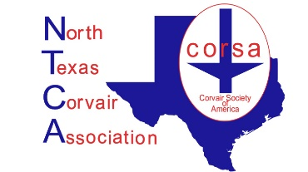
The North Texas Corvair Association Membership

Welcome to North Texas Corvair Association. We are dedicated to the preservation and enjoyment of the Chevrolet Corvair. If you own a Corvair, want to own one or used own one, a membership will add to the enjoyment of your car.

Please join us at our next meeting or event, which can be found at northtexascorvair.org/events

To become a member: Fill out this form, mail check to the address listed below form with check OR pay online at Venmo (search for NTCAPayment and look for our logo.) Bring it to our next meeting too.

Memberships are paid annual on the anniversary of joining. Active Corvair Society of America Members receive discounted dues. Dues are based on a rolling calendar year.
Dues:
$30.00 for NON CORSA Members
$25.00 for Corsa Members Please Provide Corsa Member number below
$10.00 for each additional Family member in the household

Membership will take effect upon receipt of dues

Please mail check to: NTCA, P.O. Box 170796 Irving, TX 75017
Payment can also be made using Venmo- look for NTCA Payment

Member information:
First Name: | Last Name:
Address: | Email Address:
City, State, Zip: | Phone to be reached:
CORSA member number:
Additional Family member #1 | Email address:
Additional Family member #2 | Email address:

Tell Us About Your Corvair(s) model, year, color *

